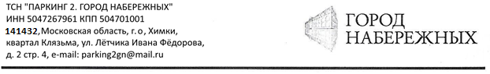

Председателю правления
ТСН «Паркинг 2. Город набережных»
Васильеву В.А.
от собственника машиноместа № ____________
_________________________________________
Ф________________________________________
И________________________________________
О________________________________________
Тел.______________________________________

ЗАЯВЛЕНИЕ
_________________________________________________________________________________________________________________________________________________________________________________________________________________________________________________________________________________________________________________________________________________________________________________________________________________________________________________________________________________________________________________________________________________________________________________________________________________________________________________________________________________________________________________________________________________________________________________________________________________________________________________________________________________________________________________________________________________________________________________________________________________________________________________________________________________________________________________________________________________________________________________________________________________________________________________________________________________________________________________________

Дата:________________________ Подпись:_________________________

